WEEK 3

Progress Report
Power BI Publishing Refresh and Fabric
Student | Kritik Dahal
Student ID | S395912
Week | Week 3
Date | 15 September 2026

Week 3 summary
This week I published my Power BI report, connected the data through a gateway, tested refresh, and started a Fabric dataflow.
Work | Status
Published report to My workspace | Complete
Created report and semantic model | Complete
Connected Excel file through gateway | Complete
Completed a successful refresh | Complete
Enabled daily refresh using Darwin time | Complete
Created Fabric dataflow and selected week7 Warehouse | In progress

Pending work
- Run the Fabric dataflow and check the SalesData table in the week7 Warehouse.
- Learn how SSAS connects with Power BI and add a short note or screenshot.

Report definition
Total Revenue is the sum of Revenue, Total Cost is the sum of Total Cost, and Total Profit is the sum of Profit. Profit Margin is Total Profit divided by Total Revenue and shown as a percentage.

Power BI publishing
The report and semantic model were published to My workspace. The report opened correctly online.
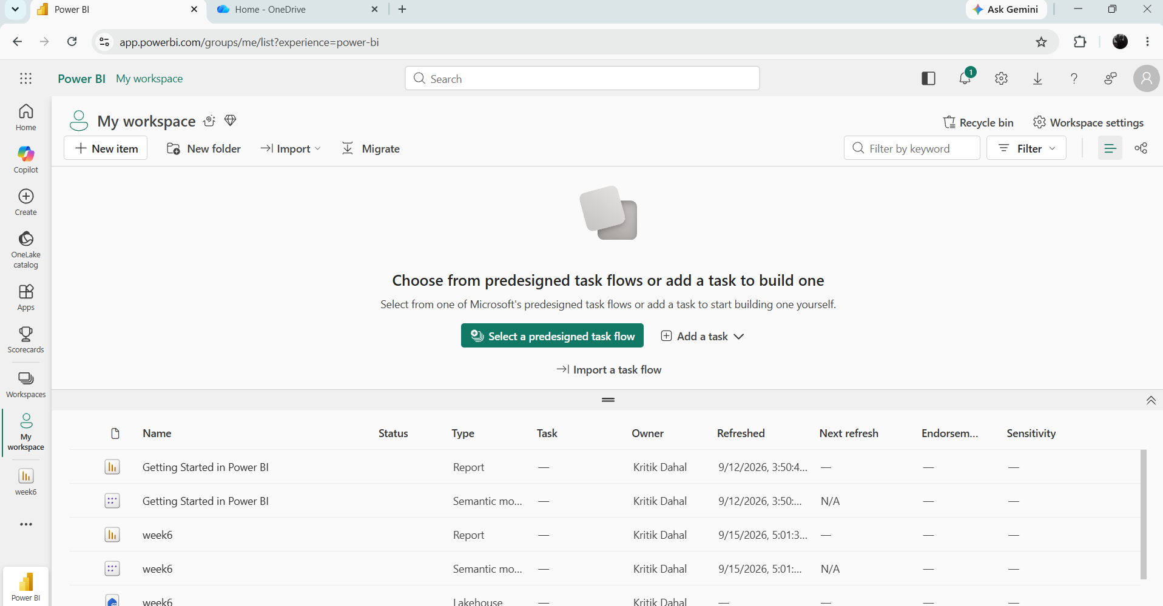
Report and semantic model in My workspace
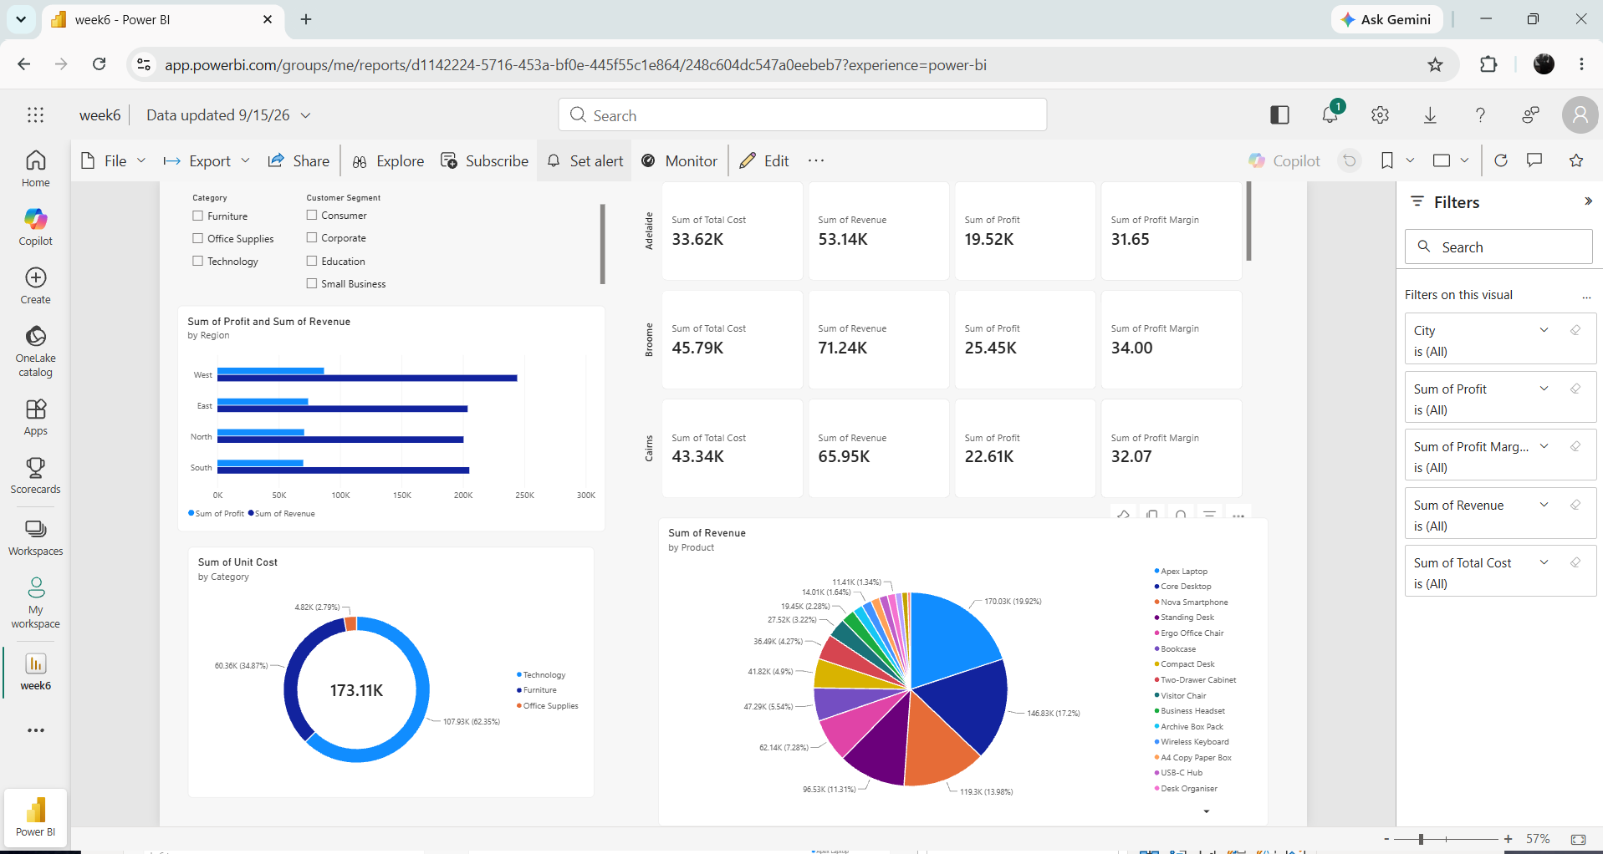
Published Power BI report

Refresh setup
The gateway refresh worked. Daily refresh is On and the time zone is Darwin.
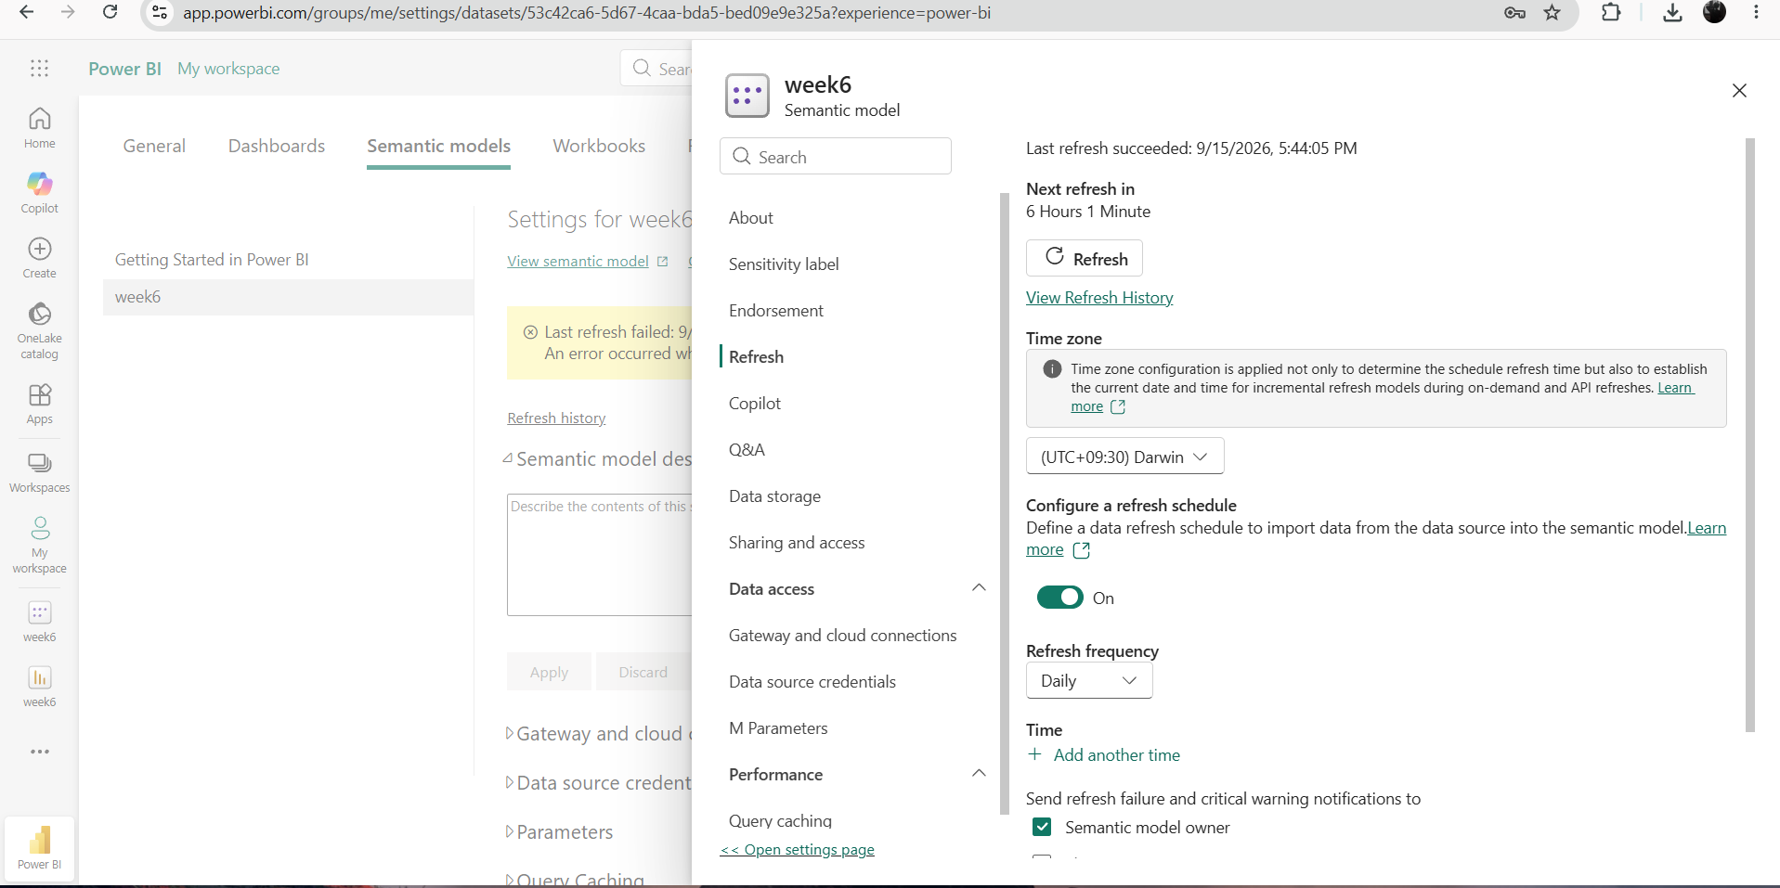
Daily refresh enabled

Fabric work
The SalesData query and week7 Warehouse are ready. The dataflow still needs to be run.
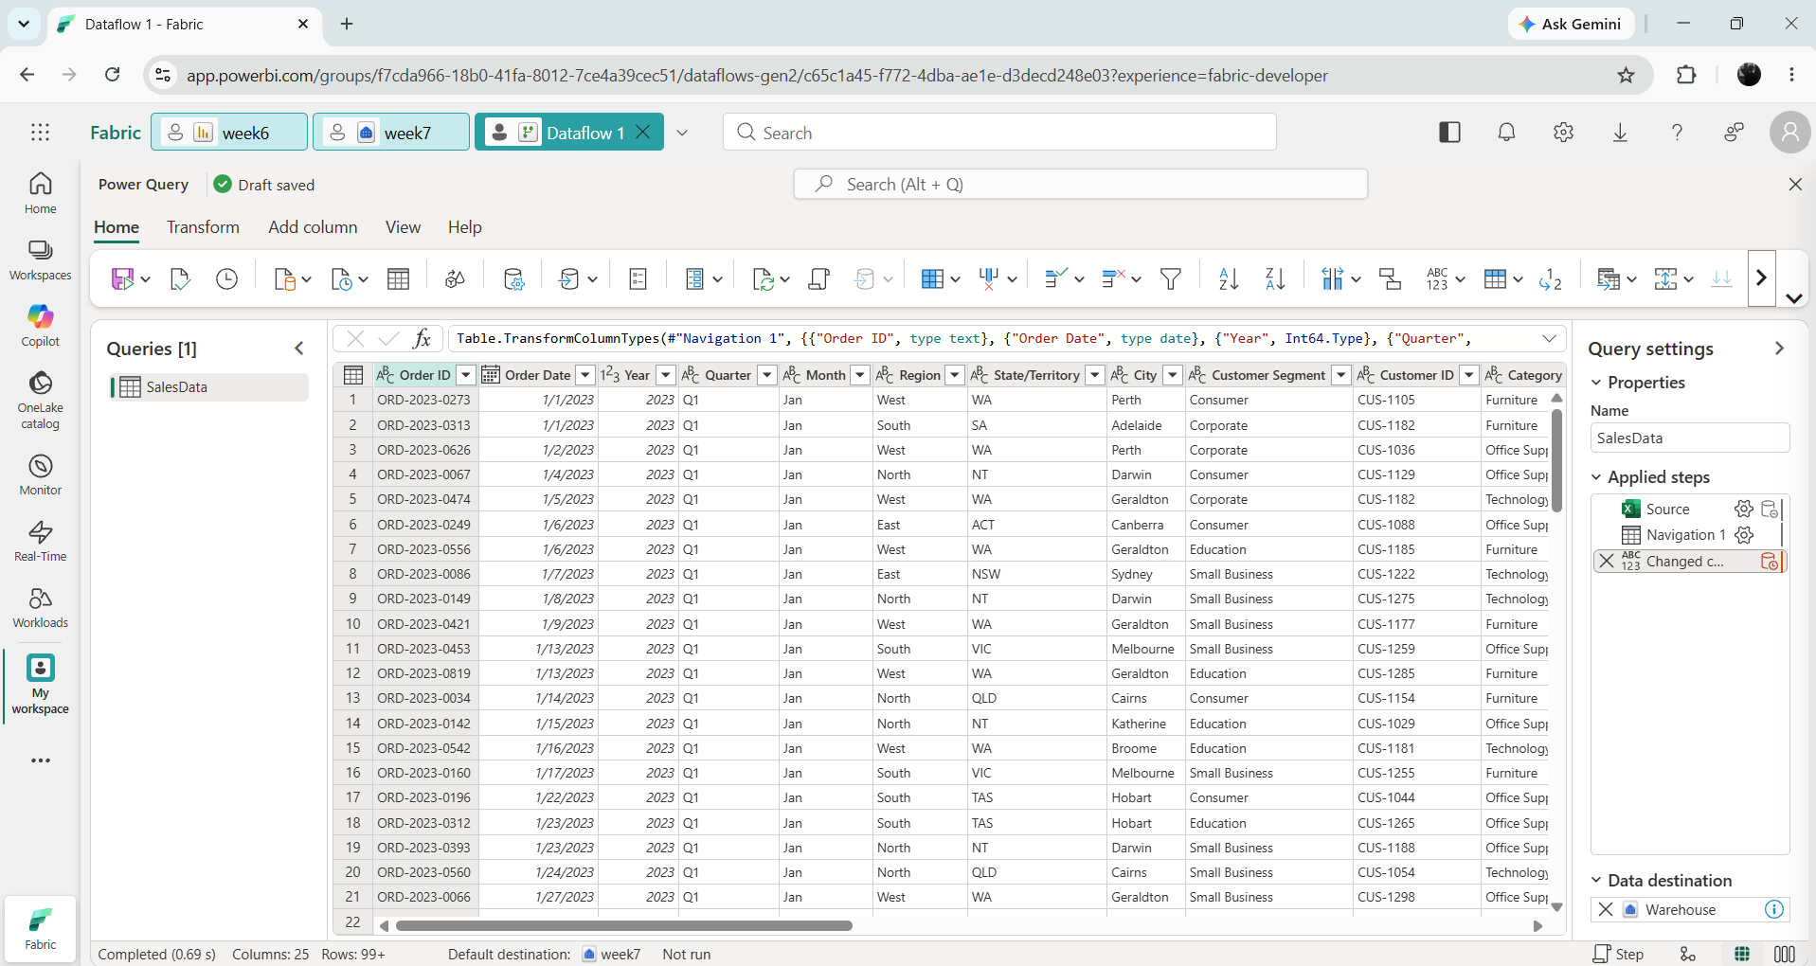
Fabric Dataflow Gen2 setup

